In this chapter we enhance the Los Boquitas application with a new component showing upcoming events in a table.

1. First, we need to have some events to display.
2. We will start by defining an event class.

Object subclass: #LBEvent

instanceVariableNames: 'who what when where'

classVariableNames: ''

category: 'LosBoquitas'

1. Next we will create accessors for the instance variables. Rather than creating the methods one at a time, you can use some of Pharo’s refactoring tools to create the methods. Select LBEvent, right-click and select ‘refactor class’ then ‘accessors’.

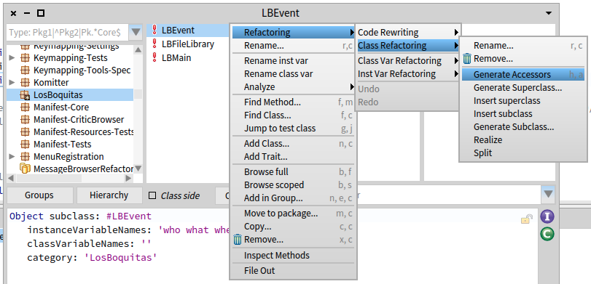

1. The refactoring tool will show you the proposed new methods and give you a chance to accept or cancel before the changes are installed. Click the ‘Ok’ button.

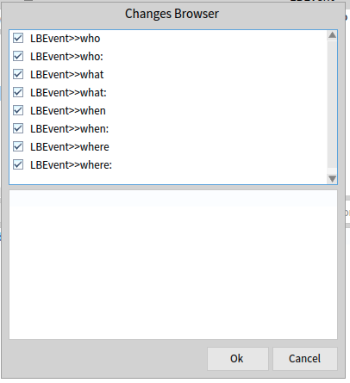

1. Add a method to support sorting the events.

<= anEvent

^self when <= anEvent when.

1. Add an initialize method to ensure that something is in each instance variable.

initialize

super initialize.

who := 'players'.

what := 'practice'.

when := DateAndTime noon.

where := 'field'.

1. Now we need a place to put the events. In most web frameworks and languages we would now start a discussion of setting up a relational database. In Smalltalk, however, we prefer to avoid the ‘object-relational impedance mismatch’ problem (see <http://en.wikipedia.org/wiki/Object-Relational_impedance_mismatch>) as long as possible. Instead of an external database that must be configured and mapped to, we will save our event objects in a *class instance variable* on the LBEvent class.
2. In the Pharo System Browser, select LBEvent in the class list and then click on the ‘*Class side*’ checkbox below the class list. This will change the class definition to a definition for the class instance variable. Edit the text area to add an ‘events’ class instance variable and save the text.

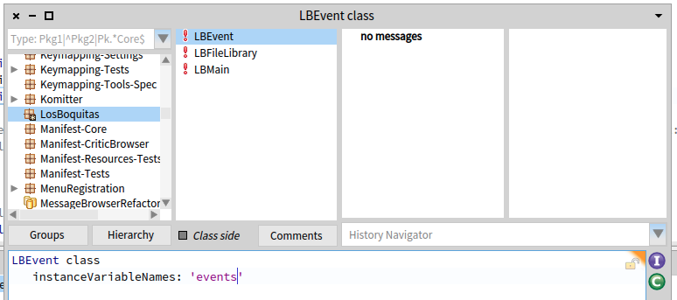

1. Now click in the method category list to get a method template. Add a *class-side* method to access the events.

events

events isNil ifTrue: [events := IdentitySet new].

^events.

1. Add a *class-side* method to create some sample events.

createEvents

"

LBEvent createEvents.

"

events := nil.

self events

add: (self new

who: 'family';

what: 'registration';

when: DateAndTime noon;

where: 'Clubhouse';

yourself);

add: (self new

who: 'players';

what: 'practice';

when: (DateAndTime noon + (Duration days: 1));

where: 'field';

yourself);

add: (self new

who: 'guests';

what: 'game';

when: (DateAndTime noon + (Duration days: 2));

where: 'Memorial Park';

yourself);

yourself.

1. In the SystemBrowser, click anywhere on the third line of the method (the one sending the ‘createEvents’ message) and press <Ctrl>+<D> (for ‘do-it’). By adding the expression to the method as a comment, we can evaluate it without having to go to a workspace.
2. Now we will define a component to display the schedule.

WAComponent subclass: #LBScheduleComponent

instanceVariableNames: 'listComponent'

classVariableNames: ''

category: 'LosBoquitas'

1. The goal is to embed this component into the main application, but for purposes of development and testing we will treat this as a stand-alone component (or application). Register the application by evaluating the following in a workspace.

WAAdmin register: LBScheduleComponent asApplicationAt: 'boquitas-schedule'.

1. Add a place-holder render method.

renderContentOn: html

html heading: self class name.

1. In a web browser, navigate to the dispatcher (<http://localhost:8080/browse>) and confirm that the new component is in the list and that it displays the class name.
2. Now we will add a real display capability to the component.
3. Add four methods to define report columns and an initialize method to create a table report using those columns.

whoReportColumn

^WAReportColumn new

title: 'Who';

selector: #who;

clickBlock: nil;

yourself.

whatReportColumn

^WAReportColumn new

title: 'What';

selector: #what;

clickBlock: nil;

yourself.

whenReportColumn

^WAReportColumn new

title: 'When';

selector: #when;

clickBlock: nil;

yourself.

whereReportColumn

^WAReportColumn new

title: 'Where';

selector: #where;

clickBlock: nil;

yourself.

initialize

| columns |

super initialize.

columns := Array

with: self whoReportColumn

with: self whatReportColumn

with: self whenReportColumn

with: self whereReportColumn.

listComponent := WATableReport new

columns: columns;

rowPeriod: 1;

yourself.

1. Now modify the render method to show the table.

renderContentOn: html

listComponent rows: LBEvent events asSortedCollection.

html render: listComponent.

1. Starting from the dispatcher (<http://localhost:8080/browse>) in a web browser, view the schedule component and confirm that it shows three rows of four columns. (Don’t click on the anchors yet!)
2. Now we will update our main application to make room for a child component.
3. Change the class schema for LBMain to add an instance variable to hold the component being displayed in the main region.

WAComponent subclass: #LBMain

instanceVariableNames: 'mainArea'

classVariableNames: ''

category: 'LosBoquitas'

1. Modify LBMain>>#renderSidebarOn: to change the heading.

renderSidebarOn: html

html div

id: 'sidebar';

class: 'section';

with: [

html heading

level2;

with: 'Menu'.

].

1. Return to your web browser and display the home page (<http://localhost:8080/boquitas>). It should have the new text now ('Menu' instead of 'Sidebar').
2. Add a menu to the sidebar.
3. Modify the sidebar render method as follows:

renderSidebarOn: html

html div

id: 'sidebar';

class: 'section';

with: [

html heading

level2;

with: 'Menu'.

**html anchor**

**callback: [mainArea := LBScheduleComponent new];**

**with: 'Events'.**

].

1. View the home page in a browser and confirm that the <Events> link is present. Clicking on it does not have any impact, but it is there!
2. We want the render method to use the mainArea component if it exists; otherwise, the image will be displayed. Modify the renderMainOn: method as follows.

renderMainOn: html

html div

id: 'main';

class: 'section';

with: [

mainArea notNil ifTrue: [

html render: mainArea.

] ifFalse: [

html image

altText: 'children playing soccer';

url: LBFileLibrary / 'boquitas.jpg';

yourself.

].

].

1. View the home page in a web browser and confirm that the event list displays when you click on the ‘Events’ link in the sidebar.
2. We now want a way to return to the home page. Modify the sidebar render method as follows:

renderSidebarOn: html

html div

id: 'sidebar';

class: 'section';

with: [

html heading

level2;

with: 'Menu'.

**html anchor**

**callback: [mainArea := nil];**

**with: 'Home'.**

**html break.**

html anchor

callback: [mainArea := LBScheduleComponent new];

with: 'Events'.

].

1. View the application in a web browser and confirm that you can switch between the image and the schedule.
2. The ‘renderMainOn:’ method in LBMain includes a conditional that hints for the need of a refactoring. Now that we have one subcomponent, we might as well have more.
   1. Create a new component:

WAComponent subclass: #LBHome

instanceVariableNames: ''

classVariableNames: ''

category: 'LosBoquitas'

* 1. Add a render method to LBHome with code from LBMain>>#’renderMainOn:’.

renderContentOn: html

html image

altText: 'children playing soccer';

url: LBFileLibrary / 'boquitas.jpg';

yourself.

* 1. LBHome is done. Now we will go back and add an initialize method to LBMain to use our new component.

initialize

super initialize.

mainArea := LBHome new.

* 1. Now we can simplify LBMain>>#’renderMainOn:’ considerably by always rendering a subcomponent instead of having conditional code:

renderMainOn: html

html div

id: 'main';

class: 'section';

with: [html render: mainArea].

* 1. Finally, we need to modify one line of the sidebar menu creation to use our new component.

renderSidebarOn: html

html div

id: 'sidebar';

class: 'section';

with: [

html heading

level2;

with: 'Menu'.

html anchor

**callback: [mainArea := LBHome new];**

with: 'Home'.

html break.

html anchor

callback: [mainArea := LBScheduleComponent new];

with: 'Events'.

].

* 1. Return to a web browser and start the application over from <http://localhost:8080/boquitas>. You should be able to switch back and forth between the home page and the schedule.

1. We would like to be able to edit events. We will start with deleting an event.
2. Add LBScheduleComponent>>#’actionReportColumn’.

**actionReportColumn**

**^WAReportColumn new**

**title: 'Action';**

**valueBlock: [:anEvent | 'delete'];**

**clickBlock: [:anEvent | self delete: anEvent];**

**yourself.**

1. Edit LBScheduleComponent>>#’initialize’ to use the new column. Note that instead of using the instance creation message ‘with:with:with:with:’ on Array, we are using an OrderedCollection and adding items to it. This is because once you reach more than four items, there might not be a class-side method that accepts enough arguments. Also note that this is an example of where the ‘yourself’ message at the end of the cascade is not just cosmetic but is necessary since the ‘add:’ method returns the argument (a column) rather than the receiver (an OrderedCollection).

initialize

| columns |

super initialize.

**columns := OrderedCollection new**

**add: self whoReportColumn;**

**add: self whatReportColumn;**

**add: self whenReportColumn;**

**add: self whereReportColumn;**

**add: self actionReportColumn;**

**yourself.**

listComponent := WATableReport new

columns: columns;

rowPeriod: 1;

yourself.

1. If you return to your web browser and refresh, the new column will likely not appear. This is because the component is still holding an instance of WATableReport that was initialize with only four columns. To see the new table you need to click on the ‘Events’ link to install a new component.
2. If you click on a <delete> link now, you should get a MessageNotUnderstood error because we have not implemented the #delete: method in LBScheduleComponent. Add the following method (and note how we are not doing any SQL or other database related activity):

delete: anEvent

LBEvent events remove: anEvent.

1. Try refreshing your web browser and note that one of the events has been removed.
2. Before you delete all the events, we will add a confirm dialog using JavaScript. Edit LBScheduleComponent>>#’actionReportColumn’ to change how the ‘Delete’ anchor is generated. Note that having the column definition in its own method means that we don’t have to edit a big method to make this change. The definition of the column is encapsulated in a single method and does not share the method with another definition.

actionReportColumn

^WAReportColumn new

title: 'Action';

valueBlock: [:each :html |

html anchor

onClick: 'return confirm(''Are you sure?'')';

callback: [self delete: each];

with: 'delete'.

];

yourself.

Here we are creating an anchor and giving it JavaScript for the ‘onclick’ event. The JavaScript code will run before the link is followed, and if the JavaScript returns false the new page is not requested.

In order for this change to be visible, you must recreate the component. A simple way to do this is to click the ‘Home’ link and then click the ‘Events’ link.

After deleting events, recreate them by evaluating ‘LBEvent createEvents’ in a workspace or using the instructions at step 2d above.

1. Save your Pharo image and quit.